



Name: ………………………………  
 Grade: ……….

**Summer Review**

**8th grade**

**Group B**

**Name: _________________**

**Teacher’s name: ___________________**

**1. Translate the words to Hebrew**

|  |  |  |  |  |  |
| --- | --- | --- | --- | --- | --- |
|  | electricity | 9 |  | environment | 1 |
|  | important | 10 |  | dining room | 2 |
|  | lamp | 11 |  | always | 3 |
|  | apartment | 12 |  | remember | 4 |
|  | cupboard | 13 |  | sometimes | 5 |
|  | living room | 14 |  | use | 6 |
|  | grade | 15 |  | hear | 7 |
|  | bathroom | 16 |  | math | 8 |

**2. Fill in the missing words from the words up**

השלימו את המילים החסרות מתוך הטבלה שלמעלה.(שימו לב יש יותר מילים ממשפטים)

1) Small houses save _________ and gas.

2) ___________ I eat ice cream in the afternoon.

3) Do you ____________ my name?

4) We __________ go to my grandparents on Friday.

5) They watch T.V in the _______________.

6) It is very ___________ to eat breakfast in the morning.

7) I like _____________, it is my favorite lesson.

8) It is very noisy, I can't __________ you.

9) My uncle lives in an _________________ in Tel Aviv.

10) People ___________ scissors to cut paper.

11) We wash our face and body in the _____________ .

12) MY friends Yuval and Matan are in the same ____________ .

**3. Complete the sentences**

השלימו את המשפטים הבאים.

tidy • lunch • years • special • months • rich • classroom

1. I am eleven …………………… old.

2. They have …………………… shoes for school.

3. There are twelve …………………… in a year.

4. Our house is always clean and …………………… .

5. The pupils clean the …………………… every day.

6. Every day at 14:00 I eat………………..with my family.

7. Mr. Roos is very……….………..He can buy anything he wants

**4.New Words- Translate the words below. תרגמו את המילים**

|  |  |  |  |  |  |
| --- | --- | --- | --- | --- | --- |
| afraid |  | interesting |  | life |  |
| animal |  | plot |  | saw |  |
| back |  | real |  | strange |  |
| like |  | always |  | wear |  |
| means |  | village |  | dangerous |  |
| movie |  | false |  | early |  |
| never |  | different |  | same |  |
| often |  | about |  | find |  |
| usually |  | kill |  | forget |  |
| was |  | sometimes |  | inside |  |
| all |  | speak |  | late |  |
| also |  | true |  | quickly |  |
| character |  | wild |  | safe |  |
| enjoy |  | forest |  | smile |  |
| fairy |  | wolf |  | stay |  |
| fairy tale |  | because |  | catch |  |
| happen |  | clothes |  | ending |  |
| magic |  | sun |  | very |  |
| nice |  | tell |  | villain |  |
| so |  | tree |  | must |  |
| parents |  | diary |  | flower |  |
| too |  | keep |  | hero |  |

**5.Write sentences with 5 of the words: כתבו משפטים עם המילים**

1………………………………………………………………………………………

2. ………………………………………………………………………………………

3. ………………………………………………………………………………………

4. ………………………………………………………………………………………

5. ………………………………………………………………………………………

6. Match the opposites: התאימו את המילה להיפוכה

villain

never

same

false

go

safe

wild

true _________

hero _________

stay _________

dangerous _________

always _________

different _________

Online review:

<http://www.englishexercises.org/makeagame/viewgame.asp?id=13485>

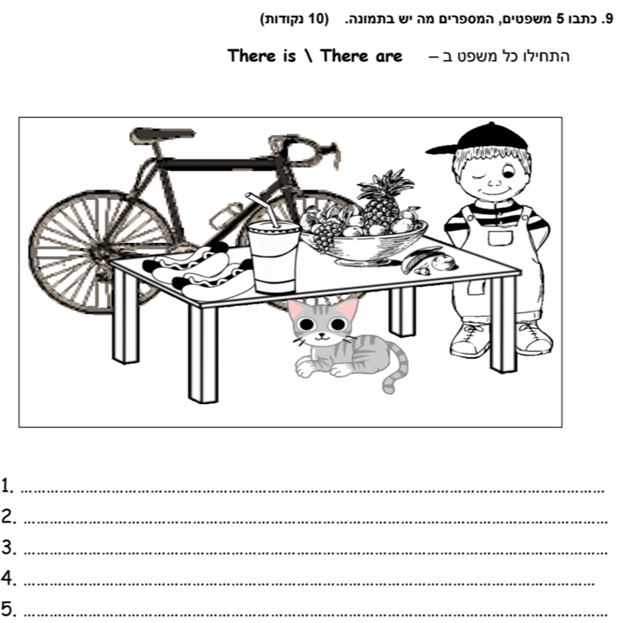

**G. Write a blog about yourself, 5-7 sentences**

כתבו בלוג על עצמכם .כתבו לפחות 5-7 משפטים. העזרו בשאלות הבאות:  
What’s your name? How old are you? Where do you live? What do you like to do in your free time? What did you do today or this week?



**קראו את הסיפור והשלימו את השאלות**

Today Grandpa is 65 years old. The family is having a party.

Everyone has a present for Grandpa. Mother gives him a box of chocolates.

Ron has warm socks for him. Sue has two tickets to a concert.

She will go with Grandpa to the concert. Aunt Betty brings him a disc man. Grandpa says, "Thank you. Now I can listen to music when I walk in the park every morning."

Even the baby, Dan, has a present for Grandpa – a big smile!

**Questions**

כתבו בטבלה את שם המתנה או את שם האדם שנותן את המתנה

|  |  |
| --- | --- |
| **Present** | **Person** |
| a box of chocolates | Mother |
| warm socks |  |
|  | Sue |
| a disc man |  |

2. Complete the sentence:

Grandpa will go to the concert with ______________.

3. Every morning Grandpa plays with...

1. the baby.
2. goes to a concert.
3. walks in the park.

4. A good name for the story is:

1. Music in the Park.
2. Grandpa and the Baby.
3. Grandpa's Birthday Party

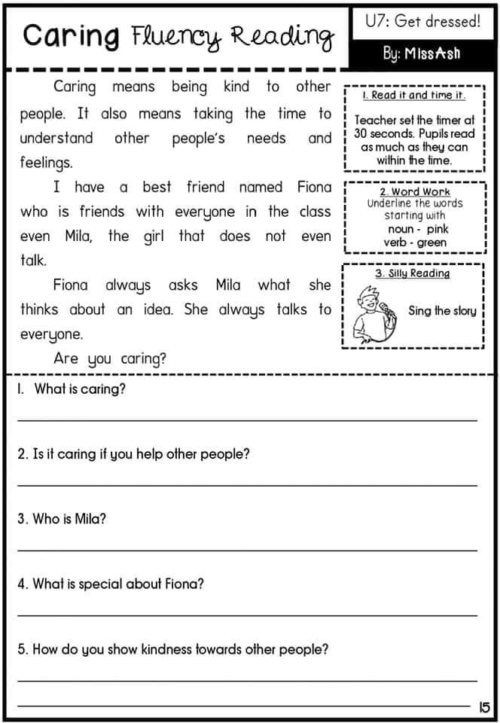

**Grammar**

**A.Complete the correct pronoun:**

he. she. It, I, they, we, you) ) השלם את כינוי גוף הנכון לפי מה שכתוב בסוגריים

1. _________ is red. (The table).

2. _________ is very tired. (My father)

3. _________ are watching T.V. (My brothers)

4. _________ are friends. (Moti and I)

5. _________ like to sing. (You and Avi)

6. _________ is playing with her dog. (The girl)

7. _________ has many flowers. (The tree)

8. _________ go to the cinema every Saturday. (My friends and I)

9. ________ is baking a chocolate cake now. (My mom)

10. _______ has brown eyes. (My father)

**B. She, he, it, we, they כתבו בכל משפט את שם הגוף המתאים**

1. Sapir is my neighbor.

____________ is in my class.

2. Ron and I like basketball.

____________ are good players.

3. Noa and I have two dogs.

____________ have green eyes.

4 . Ben has a new ball.

________ is red.

**C. Verb to be – Present Simple: am, is , are**

**Complete with am, is ,are השלימו עם**

1. My mother__________ a tall woman.

2. The babies__________ cute.2

3. Dana and Michal __________ sisters.

4. I __________ happy.

5. Ronen __________ a very good student.

6. Dan and I __________ tall.

7. Maya and Dan __________in the same class.

8.The children__________ thin.

9. The mice__________ very small.

10. My teacher __________ a nice person.

**F Complete the sentences**

**have, has , am, is, are השלם את המשפטים עם:**

1. The computer………………on the shelf.

2. My friends and I ………………..at school.

3. I ………………….a good pupil.

4. Suzy………………………….my best friend.

5. You……………………..two sisters and one brother.

6. She ……………….a big green bag

7. Bananas …………………….yellow.

8. They …………….. a tall teacher.

9. He …………… a new computer.

10. Bobby _______ a special dog.

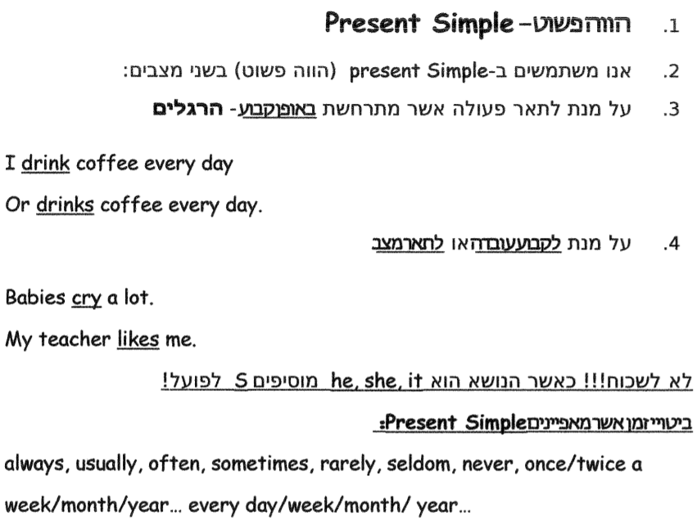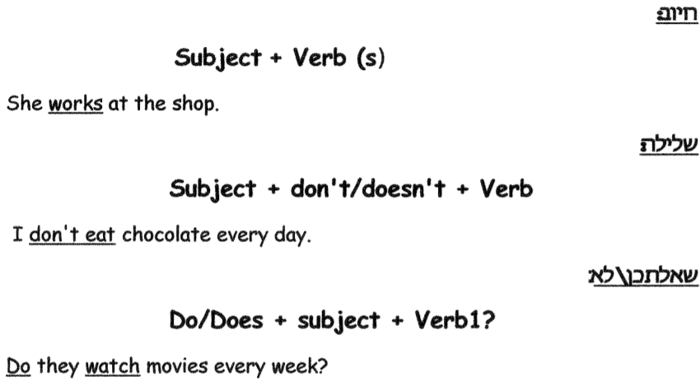

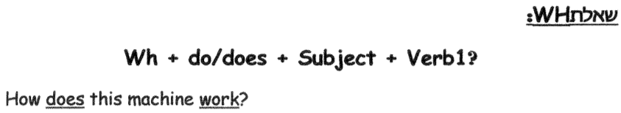

1. Write the translations of the words. כתבו פירושים לביטויי הזמן

1. every morning ___________2. sometimes ___________ 3. always _________

4. never ________________ 5. often ______________ 6. once a year ________

7. usually ________________ 8. Twice a month ______________

B. **Circle the correct word**

1. My mother **talks/talk** on the phone all day.
2. My father never **forget/forgets** to give me money.
3. You **cleans/clean** your room every day.
4. He **don’t / doesn’t** want to wear the jacket.
5. Peter and Jeff **plays/play** football on the weekend.
6. It **doesn’t/don’t** make a noise.
7. She **study/studies** French.
8. The sun **go/goes** down every evening.
9. Complete the sentences with the correct form of the verb in the present simple השלימו את המשפט עם הצורה הנכונה של הפועל בהווה פשוט.
10. My cat _________________ (sleep) all the time.
11. We ___________(play) tennis every day.
12. My father usually _____________(read) a newspaper in the morning.
13. Donna ___________________(not listen) to music all the time.
14. Ronny ___________________ (not visit) his friends once a week.
15. __________she usually ______________(buy) her clothes in Paris?
16. The Japanese _____________(not eat) Humus.
17. __________ he usually __________(work) this hard?
18. They ______________(not ride) a car.
19. _________ Gil and Shira usually _____________(do) their homework together?
20. **Write the questions to the answers.   
    כתבו שאלות לתשובות. שימו לב, התשובה היא המילה המודגשת בקו תחתון**
21. ______________________________________________________  
    I live in Israel.
22. __________________________________________  
    I like to play basketball.
23. __________________________________________  
    I buy music disks and T shirts with my pocket money.
24. __________________________________________  
    Dana works at the animal clinic, because she likes animals.
25. __________________________________________  
    The bus leaves at 1:30 every day.

GOOD LUCK