



Name: ……………………………… Grade: ……….

**Summer Review**

**8th grade**

**Group A**

**Name: _________________**

**Teacher’s name: ___________________**

**Makif Chet Summer Work 8th Grade Name: _________**

**Vocabulary:**

**1. Replace the words in bold with the words from the bank. (There are two extra words) (8p.) החליפו את המילים המודגשות במילה המתאימה מהמחסן.**

**especially /unbelievable /refused / courts / gym /retire / succeeded / recognize/ developed /athlete**

1. When he was in school, he **did very well** in history. __________________
2. Our school built **a new place** to play tennis. ________________________
3. You change your hair cut! I didn’t **know it was** you! _________________
4. Dan asked his sister to help him with his homework, but she **said no**. ___________
5. When I am 65, I’ll **stop working**. _________________
6. Omri Caspi is a famous Israeli **sportsman.** _________________
7. Dan enjoys all sports, but he **really** likes football. ___________________
8. The teacher told us a **very surprising** story. _____________________

**2. Complete the sentences with the words below**. **(There are some extra words) (16p.)**

**crashed/ options/ choice/ landed/ in shape/ instructions/ emergency/ survived/ the first sign of trouble/ contact/ inform**

1. You have two ___________________. You can do the dishes or wash the floor.

2. When you take a test, you need to read the ______________________ first.

3. The pilot needed to return to the airport to make an __________________ landing.

4. It was a serious car accident, but everyone _____________________.

5. The police must act quickly at ________________________.

6. This man is 78 years old but he is still ______________________.

7. The plane __________________ in a field.

8. Shiri doesn’t know about the meeting. Can you ___________________ her?

**Grammar**

**Present Simple**

1. **Fill in the correct form of the verbs in brackets. Use the Present Simple tense.**
2. Mother and father ____________ (drink) coffee every morning
3. Rina __________________ (not go) to work on Saturday
4. __________Adir ___________ (have) three dogs?
5. It _____________________ (not rain) in summer
6. Tom and Jerry __________________ (be) good animals.
7. My friends and I ___________________ (not watch) much television.
8. Betty ______________ (wash) the car once a week
9. Dana and Lior ______________ (play) basketball everyday
10. At the end of the film, the hero ______________ (kiss) the pretty girl.
11. Fred _________________ (study) English four times a week.
12. My mother always ________________ (do) the shopping.
13. ___________your father ___________ (read) a newspaper every day?
14. Fred ____________________ (not take) the bus to school every day.
15. My parents _________________ ( not play) tennis on Saturday.
16. Most children _____________ (crawl) before they _____________ (walk).

**Past simple**

**A.Complete the sentences with the correct form of the verb in the Past Simple, pay attention to irregular verbs.**

1. Yesterday we _______________ (work) in the garden. It ________(be) late.
2. __________ you________________ (play) tennis last night? Yes, I ______________
3. I ________________(buy) a skirt last Monday. I _______________ (not like) the color.
4. We ________________(drive) home late and _________________ (not park) the car.
5. Mira _____________(tidy) her room and __________(be) happy to do it.
6. ____________son______________ (walk) the dog an hour ago?
7. _____________ the pupils _____________(need) time for the test?
8. The lessons _______________(begin) at 08:00 o’clock but I __________________ (not get up) on time.
9. We ____________(eat) chips yesterday and it _______________ (not be) salty.
10. I _______________(catch) the bus at night, I _________________ (not miss) it.
11. The plates _______________(slip) from my hands and _____________(break).

**B.Write 5 sentences about what you did last week:**

1. _____________________________________________________________________
2. _____________________________________________________________________
3. _____________________________________________________________________
4. _____________________________________________________________________
5. _____________________________________________________________________

**Reading- Read and answer.**

|  |
| --- |
| **What’s Your Emergency?**  Do you know what number to call in an emergency? In Israel and many other countries, there are several numbers to call for help. But in the United States, there is only one number – 911.  **1**  In the past, there were so many phone numbers to call in an emergency that people didn’t know which one to use. For example, in Los Angeles there were more than 50 different numbers. In 1968, there was a decision1 to use one emergency number, 911, for the whole country. Today, over 500,000 people call 911 for help every day.  **2**  5  10  15  20  20  20  The person who answers calls to 911 is called a dispatcher2. Dispatchers must study for six months to learn how to answer emergency calls correctly. The first question they must ask is, “What’s your emergency?” The next question they have to ask is where the caller is. The dispatcher immediately sends the information to the police, firefighters or ambulance services3 while he or she continues to talk to the caller. It’s a difficult job, and dispatchers have to remain calm in very serious situations, such as fires and crimes.  **3**  Sometimes there are calls to 911 that have a happy ending. Danielle Huffman,  a 911 dispatcher in Iowa, had this experience. A man called and said his wife was having a baby, and it was too late to go to the hospital. Danielle helped him over the phone and later got to meet the happy family.  **4**  It is a hard job, but James Marks, a dispatcher in Los Angeles, is happy. He says, “I know that I am doing something very important for my city and its people.”  **5** |

1decision החלטה / قرار 2dispatcher מוקדן / مرسِل 3services שירותים / خدمات

B ***Answer the questions about the article.***

**1** Complete the sentence.

According to paragraph 1, people in Israel don’t have

.

**2** Before 1968, in the United States, …. (paragraph 2)

a. there were many different emergency numbers

b. every city had 50 different emergency numbers

c. people called 911 when there was an emergency

d. it was easy to remember what emergency number to call

**3** Circle the TWO correct answers.

What information in paragraph 3 did you learn about 911 dispatchers?

a. They first ask the caller’s name.

b. They don’t panic during an emergency.

c. They study for two years.

d. They need to find out the caller’s address.

e. They give information to the police after the end of the call.

**4.** Complete the sentence.

According to paragraph 3, fires and crimes are examples of ………………………………………………………………………………………………………………………………………………………………………………………………………………………………………………………………………………

**5.** Dispatchers always ask the same two questions first. (paragraph 3)

Explain why these questions are so important.

……………………………………………………………………………………………………………………………………………………………………………………….

6. Write T (**True)** or F (**False)**. (paragraph 4)

...... 1. Danielle met the parents and their baby.

...... 2. Danielle went to help a woman who was having a baby.

**7** According to paragraph 5,James Marks likes being a 911 dispatcher   
 because he …

a. works in Los Angeles

b. helps the people in his city

c. works hard

d. enjoys happy endings

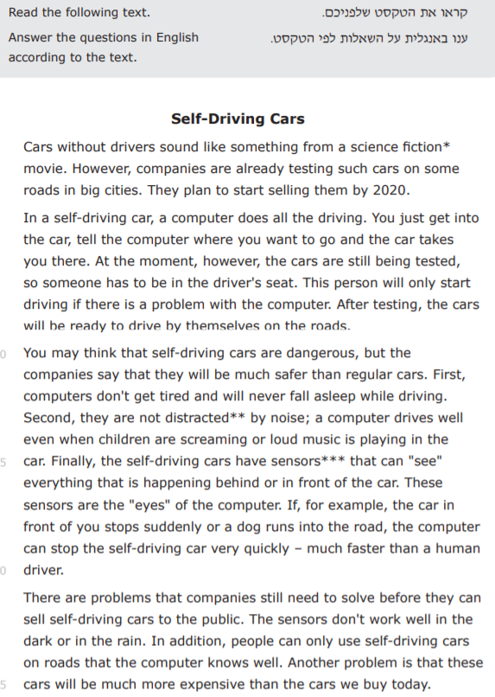

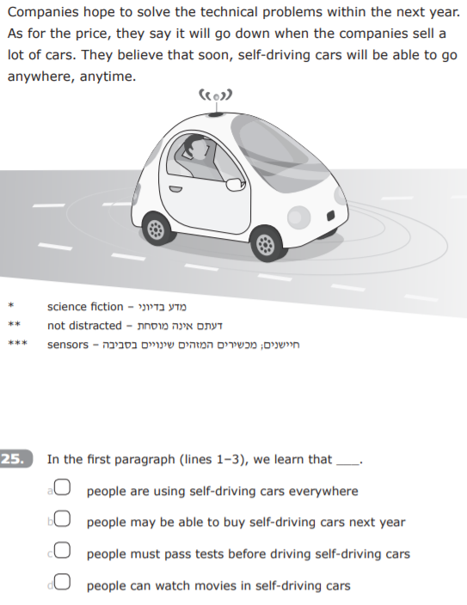



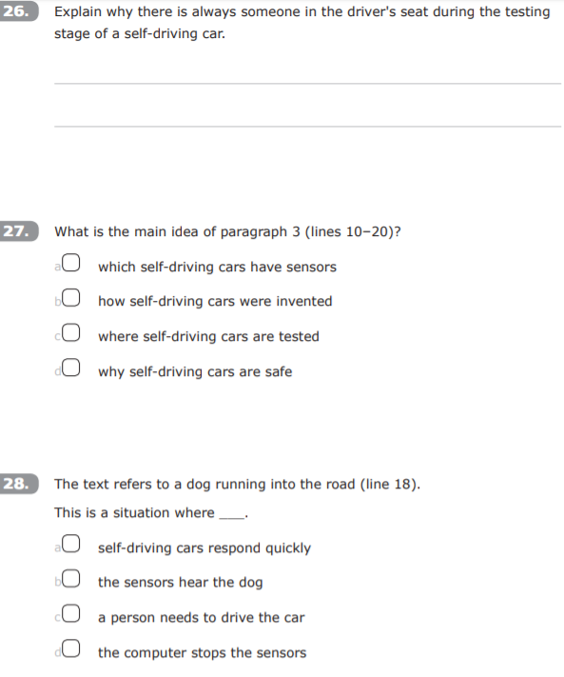

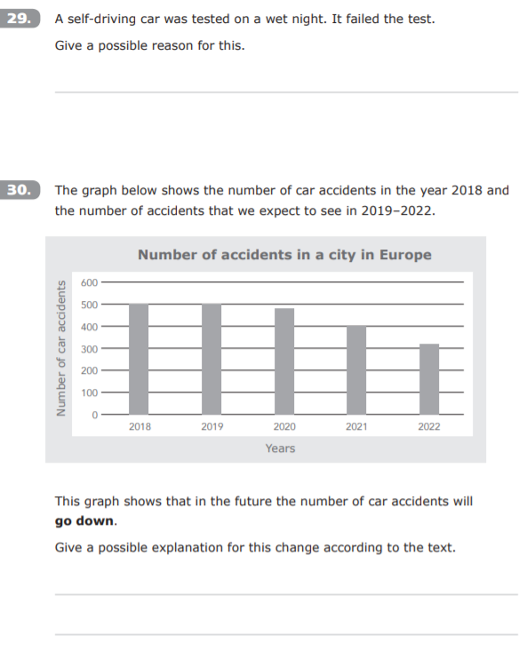



**Write here 10 new words from the text:**

**1.__________ 2. ____________ 3. _________ 4. ______________**

**5. ______________ 6. ______________7. ______________ 8. ______________**

**9. ______________ 10______________**

Write 5 sentences with 5 of the new words.

1. _____________________________________________________________________
2. _____________________________________________________________________
3. _____________________________________________________________________
4. _____________________________________________________________________
5. _____________________________________________________________________

**Writing**

**Write about one of the most important persons in your life (a member of your family or a friend). Pay attention to spelling, grammar, and punctuation. Write 50-60 words.**

* Who is it? How old is he/she?
* Give information about the person: job, hobbies.
* Why is this person important to you?
* When and how this person helped you succeed in something?

______________________________________________________________________________________________________________________________________________________________________________________________________________________________________________________________________________________________________________________________________________________________________________________________________________________________________________________________________________________________________________________________________________________________________________________________________________________________________________________________________________________________________________________________________________________________________________________________________________________________________________________________________________________