**Summer Review**

**7th grade**

**Group B**

**Name: _________________**

**Teacher’s name: ___________________**

כינויי גוף - Pronouns

**רשמו ליד כל כינוי גוף את הפירוש המתאים.**

He You They

I She

It We

**השלימו את הטבלה עם המילים הבאות.**

Ben, sister, Tal and you, a boy, books, Alon, pupils, Dana and I , a dog ,Coral , a flower , father , children, Gal and I ,dad, Ron and Dan, friends , a ball, the cat and you , mother ,sun, Ronit, girls , school, table, apples, snake, woman, dad, you and Ronny, David

|  |  |  |  |  |  |
| --- | --- | --- | --- | --- | --- |
| He | We | it | they | she | You |
|  |  |  |  |  |  |
|  |  |  |  |  |  |
|  |  |  |  |  |  |
|  |  |  |  |  |  |
|  |  |  |  |  |  |

**כינויי גוף - Pronouns**

**בחרו בתשובה הנכונה מתוך כינויי הגוף שלמדתם.**

1. This man is my father.

_____ is my father.

2. Dalia is a girl.

_____ is a girl.

3. Danny and Ben are boys.

_____ are boys.

4. Pussy is a cat.

_____ is a cat.

5. Rona and I are in the class.

_____ are in the class.

6. This woman is my mother.

_____ is my mother.

7. Nora is my teacher.

_____ is my teacher.

8. Mother is a teacher.

_____ is a teacher.



36

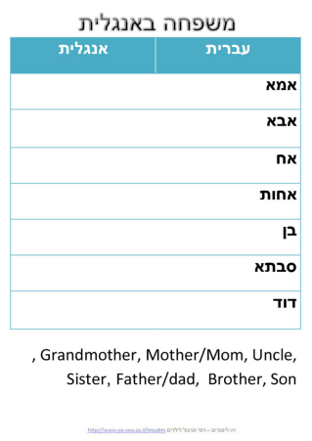

7

**השלימו את הפרטים החסרים לגבי משפחתכם.**

1. My mother's name is ____________________________. 2. My father's name is ____________________________. 3. I have _______________________________ sister(s). 4. I have ______________________________ brother(s). 5. I am my parent's son / daughter.

6. I have _______________________________ uncles. 7. I have _______________________________ aunts. 8. My mother is my father's ________________________. 9. My father is my mother's ________________________. **10.**My favorite person in my family is my _______________**.**

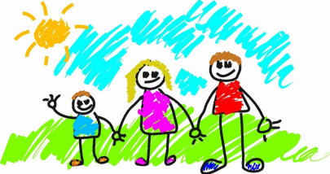9

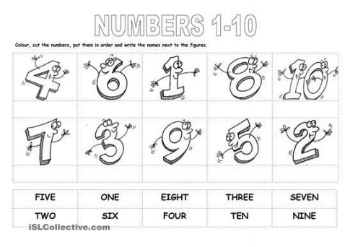**התאימו בין המספר לשמו באנגלית.**

6 one   
 8 four

2 nine

4 eight

7 five

10 six

1 ten

5 three

3 two

9 seven

12

**כתבו את שמות ימי השבוע באנגלית.**

יום ראשון ____________________________________________ יום שני ___________________________________________   
יום שלישי _____________________________________________

יום רביעי ______________________________________________

יום חמישי ______________________________________________

יום שישי _______________________________________________

יום שבת _________________________________________________

איזה יום היום? _______________________________________

איזה יום היה אתמול? __________________________________

איזה יום יהיה מחר? ___________________________________

שלשום היה _________________________________________

מחרתיים יהיה _______________________________________

מהו היום שאת/ה הכי אוהב/ת ___________________________?

**כתבו את שמות חודשי השנה באנגלית.**

ינואר _________________________________________________ פברואר _______________________________________________

מרץ _________________________________________________ אפריל ________________________________________________

מאי _________________________________________________

יוני _________________________________________________ יולי _________________________________________________ אוגוסט ______________________________________________ ספטמבר _____________________________________________ אוקטובר _____________________________________________

נובמבר ______________________________________________ דצמבר ______________________________________________

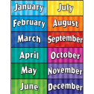

קראו את הקטע וענו על השאלות שאחריו

Ben is a student. He likes football and music. He listens to music every night. He plays basketball in the summer only, when it does not rain. He plays three times a week in June, July and the month of August. That is why summer is his favorite time of the year.

1) Who is the story about? _______________________________ 2) What does Ben like (two things)? ________________________. 3) Which time of year does he like best? _____________________. 4) Why does he like summer? ______________________________.

**כתיבה Writing**

כתבו 5 משפטים המתארים את החבר הכי טוב שלכם

Write 5 sentences describing your best friend.

1. _____________________________________________________________________



Write 5 sentences about your daily routine.  
 כתבו 5 משפטים על דברים שאתם עושים ביום יום שלכם.

1. _____________________________________________________________________ 2. _____________________________________________________________________ 3. _____________________________________________________________________ 4. _____________________________________________________________________ 5. _____________________________________________________________________