



**Summer Review**

**7th grade**

**A**

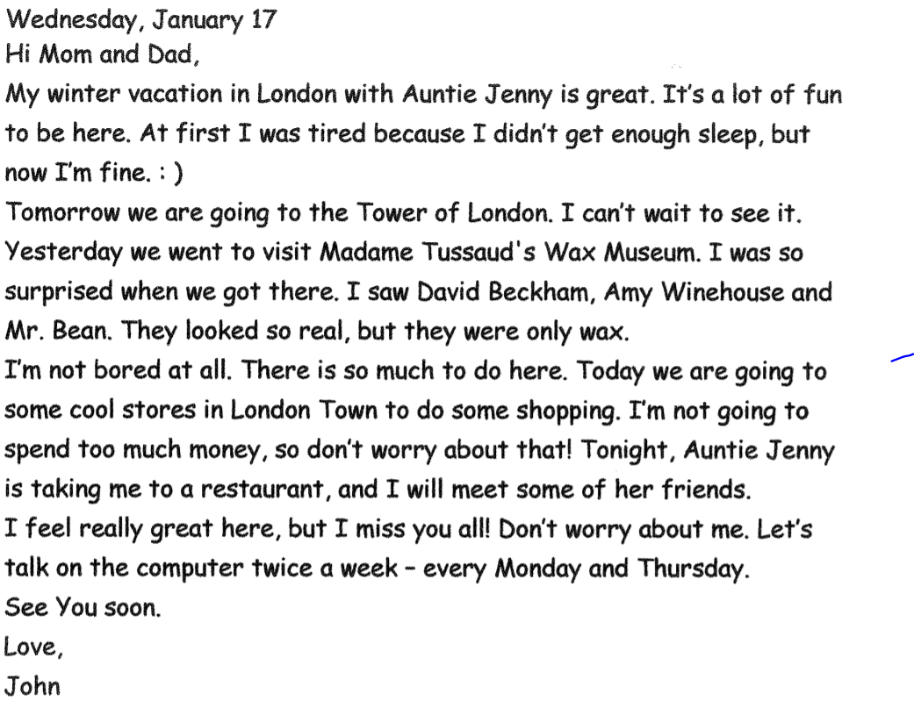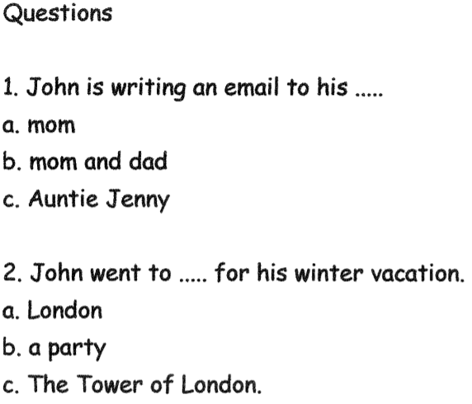

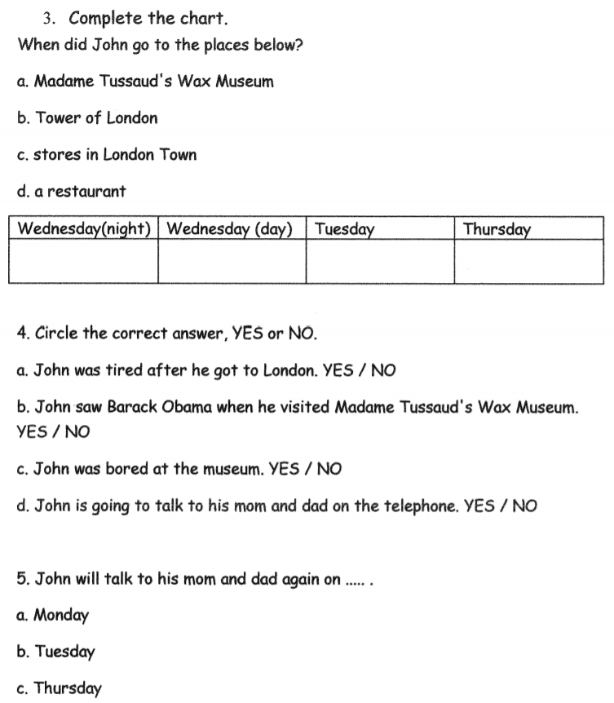

**Write here 10 new words from the text: כתבו 10 מילים חדשות מהטקסט.**

**1.__________ 2. ____________ 3. _________ 4. ______________**

**5. ______________ 6. ______________7. ______________ 8. ______________**

**9. ______________ 10______________**

Write 5 sentences with 5 of the new words. כתבו חמישה משפטים עם המילים

1. _____________________________________________________________________
2. _____________________________________________________________________
3. _____________________________________________________________________
4. _____________________________________________________________________
5. _____________________________________________________________________

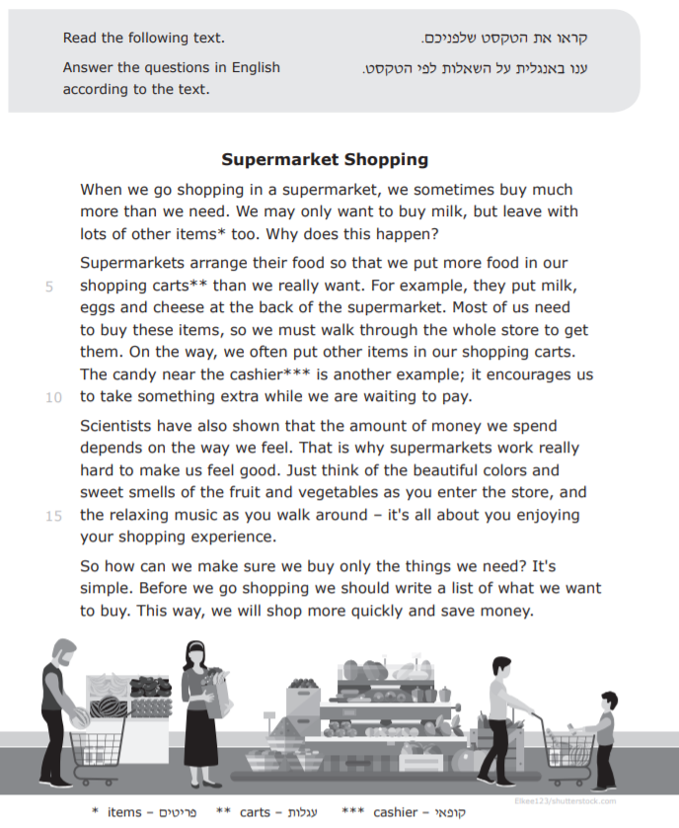

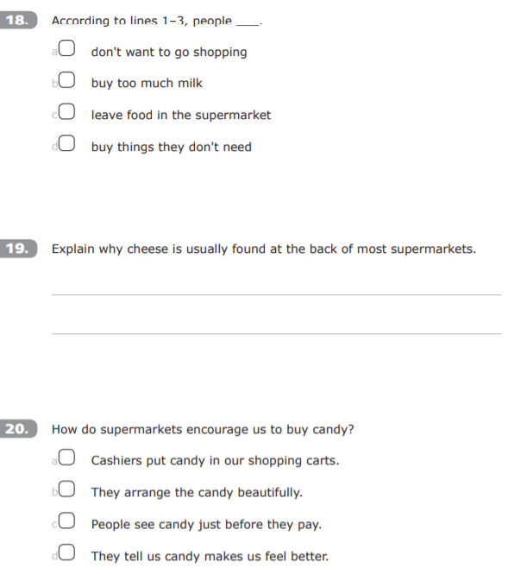

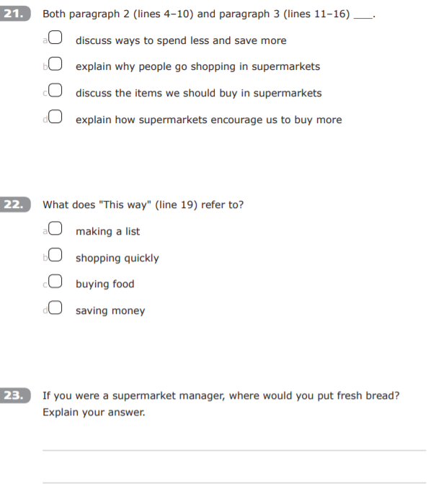



**Write here 10 new words from the text:**

**1.__________ 2. ____________ 3. _________ 4. ______________**

**5. ______________ 6. ______________7. ______________ 8. ______________**

**9. ______________ 10______________**

Write 5 sentences with 5 of the new words.

1. _____________________________________________________________________
2. _____________________________________________________________________
3. _____________________________________________________________________
4. _____________________________________________________________________
5. _____________________________________________________________________

**Vocabulary**

1. **Write the words in the correct columns**

מיין את המילים בטבלה שלפניך

|  |  |  |
| --- | --- | --- |
| **Noun** | **Verbs** | **Adjectives** |
|  |  |  |
|  |  |  |
|  |  |  |
|  |

|  |
| --- |
| Detective, collection, try, important, catch, hill, amazing, give up, heavy |

**2. Circle:** הקף את המילה המתאימה בכל משפט

1. Yesterday, a new **pupil / purple / people** came to our class.

2. Mom is working in the **chicken / kitchen** at that moment.

3. **Where / were** do you live?

4. I need a new dress **for / four** my party.

5. You have to **live / leave** the house early in the morning.

6. There is a **wait / white** flag at the beach.

7. I **see / sea** two girls next to the red car.

8. The **sun / son** is shining in the sky.

9. I **no / know** that you are coming to visit me.

10. There are **to / two** chairs in the room.

**Grammar**

**A Complete the sentences with the correct form of the verbs**

**in brackets. Use the Present Simple.**

1. We often .............................. (turn on) the fan in the summer.

2. Many birds .............................. (fly) south before the winter.

3. .............................. you .............................. (wake up) early on Sunday?

4. Mike and Kate .............................. (not work) in the evening.

5. Ice .............................. (not melt) at -30°C.

6. Sarah .............................. (live) near the sea.

7. The teacher _____________( not teach) the class English every day.

8. We______________ (brush) our teeth every morning.

9. David _____________(go) to work every day.

10. The baby __________(cry) every time but he _______________ (not want) to eat.

11. Dan and Dina ___________(play) together every break.

12. I __________(ride) my horse every afternoon.

13. They __________(bring) lunch to school every day.

14. We __________(read) English books every afternoon.

**B. Complete the sentences with the correct form of the verbs in brackets. Use the Past Simple.**

1. Many people in the village .............................................. (not survive) the flood.

2. The plane ............................................. (not take off) on time because of the storm.

3. Alice ............................................. (not arrive) on time for dinner, so her parents were

angry.

**C. Complete the news report with the correct form of the verbs below. Use the Past Simple, positive or negative.**

|  |
| --- |
| manage to hit drop get hurt  try have know say |

**Snowstorm on the Mountain**

Five young skiers were on the mountain yesterday when the snowstorm   
1. .............................. . A helicopter with rescue workers 2. .............................. to reach them, but didn’t succeed because the wind was too strong. During the night, the temperature 3. .............................. to -15 degrees Celsius! Early this morning, the helicopter returned to the area and rescued some of the skiers, but it 4. .............................. to rescue them all. After the third trip, all five of the skiers were finally together again.

“We 5. ............................. about the storm before we left,” 6. .............................. Tom Banks, the youngest skier in the group. “When the storm began, we were worried. We were cold and we 7. .............................. enough food.”

“Luckily, they 8. .............................. ,” said the doctor, after he checked them all.

F. **Complete the sentences about a hike with the modals and**

**semi-modals below. Use each one once.**

may mustn’t have to should can’t

1. You .............................. arrive by 7:00 so we can leave on time.

2. You .............................. leave the group because it’s dangerous.

3. Stay away from snakes. They .............................. be dangerous.

4. It is very hot. You .............................. wear a hat and drink a lot of water.

5. We will hike in places where you .............................. use your cellphones

**Writing**

**How do you usually spend your time on the Summer Vacation? Write a short paragraph using the questions below to help you. Remember to use capital letters and correct punctuation.**

What do you do when the weather is nice?

Who do you spend time with?

What games do you play / sports do you do?

When do you go to bed?

_____________________________________________________________________________________________________________________________________________________________________________________________________________________________________________________________________________________________________________________________________________________________________________________________________________________________________________________________________________________________________________________________________________________________________________________________________________________________________________________________________________________________________________________________________________________________________________________________________________________________________________________________________________________________________________________________________________________________________________________________________________________________________________________________________________________________________________________________________________________________________________________________________________________________

Good luck and have a fun summer! :)